1. MKDIR ELT : To create a new directory with the name “ELT”
2. Create a file Script_ELT.py (File created in the elt folder)
3. Create a docker-compose.yaml (File created in the elt folder)
4. Create a docker file (file created in the elt folder
5. Sequence of the files is mentioned in the below screenshot.

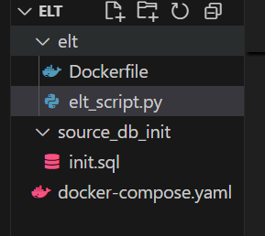

1. After configuration of all the files is completed, Run the below commands in CMD
2. **Docker compose up** : Builds, recreates, starts and attaches to containers for a service.
3. **Docker compose down**: Stops containers and removes containers, networks, volumes and images created by up.
4. **Check if you can see the containers, Network, Volumes in the docker desktop application**. If everything looks good go and inspect the data in the source and destination containers.

____________________TO CHECK DATA IN DESTINATION CONTAINER________________________

1. **docker exec -it elt-destination_postgres-1 psql -U postgres** :

exec : Executes a command in the running container

-it :

**elt-destination_postgres-1:**  Name of the destination db container.

**Psql**: Database Type

**-U postgres:** -U is for user and postgres is the user name.

1. **\c destination_db :**  To connect to the destination db
2. **\dt :** to check the tables in the destination_db
3. **Select * from table names:** Try to check if the data is correct in the destination db

____________________TO CHECK DATA IN SOURCE CONTAINER________________________

1. **docker exec -it elt-source_postgres-1 psql -U postgres** :

exec : Executes a command in the running container

-it :

**elt-source_postgres-1:**  Name of the destination db container.

**Psql**: Database Type

**-U postgres:** -U is for user and postgres is the user name.

1. **\c source_db :**  To connect to the source db
2. **\dt :** to check the tables in the source_db
3. **Select * from table names:** Try to check if the data is correct in the source db.